CREATE TABLE STUDENTNEW(Student_reg NUMBER(30),Student_Name VARCHAR2(38),Student_dob DATE);

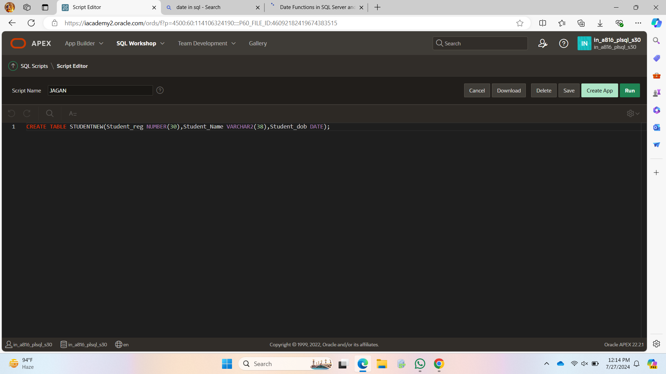

ALTER TABLE STUDENTNEW ADD BLOOD_GROUP VARCHAR2(30);



ALTER TABLE STUDENTNEW ADD PRIMARY KEY (STUDENT_REG);

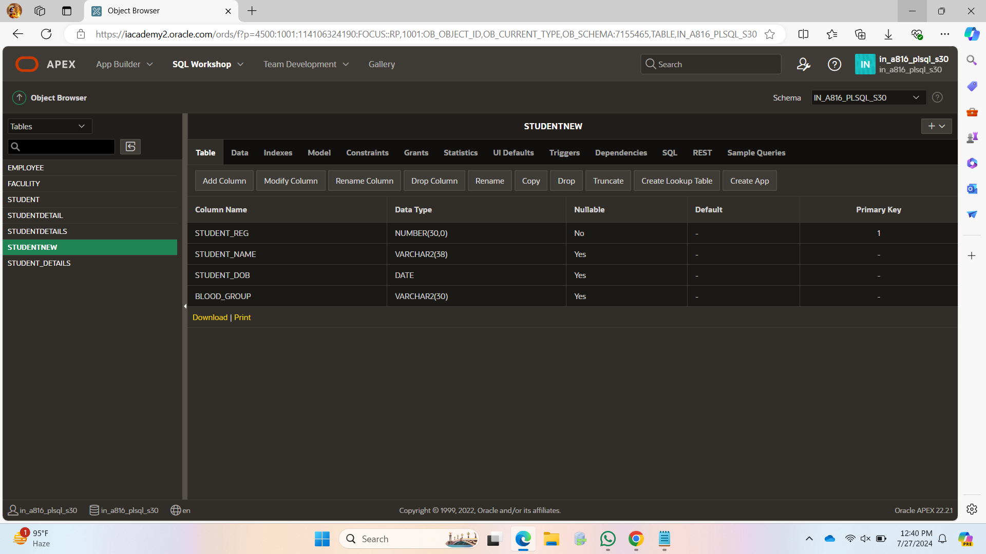

ALTER TABLE STUDENTNEW ADD USELESS VARCHAR2(30);

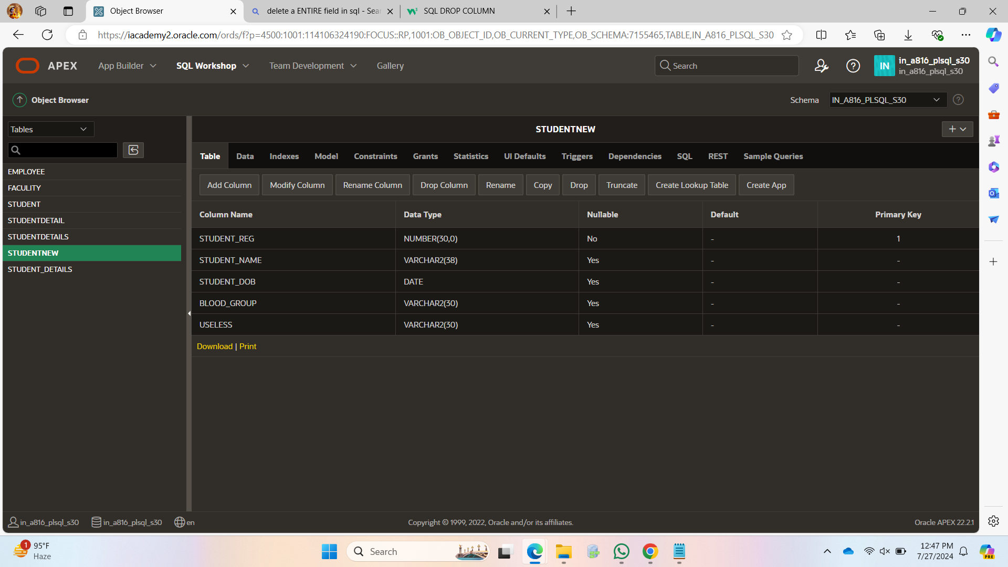

ALTER TABLE STUDENTNEW DROP COLUMN USELESS;

